Copyright Notice:

©2006 IEEE. Personal use of this material is permitted. However, permission to reprint/republish this material for advertising or promotional purposes or for creating new collective works for resale or redistribution to servers or lists, or to reuse any copyrighted component of this work in other works must be obtained from the IEEE.

Broadband Omnidirectional Helmet Antennas

Johnson J. H. Wang
Wang Electro-Opto Corporation (WEO)
Marietta, Georgia 30067 USA
Phone: (770)-955-9311 Email: jjhwang@weo.com

I. Introduction
A helmet is generally worn in the field by soldier, police, firefighter, forest worker, and motorcycle rider, etc. The helmet-mounted antenna is the only antenna carried, borne, or worn by them that can possibly have a true and stable omnidirectional radiation pattern because of its uniquely high and unobstructed field of view and its stable orientation independent of the posture and movement of the wearer (since the head is generally held upright). However, the helmet antenna must compete against other helmet-mounted applications for this premium location. It must also have minimal weight, size, radiation hazard, and be wearable. Fundamentally, it must compete against whip and vest antennas on every aspect, including costs.
To be allowed a permanent spot on the precious location of a helmet, the antenna must as a rule be broadband/multifunction. In the open literature, Wang et el [1-2] reported a smart broadband helmet antenna, which appears to be the first smart personal antenna developed. Adams et el [3] discussed a 0.5-2.0 GHz helmet antenna. Lebaric and Tan [4] described the development of a 0.3-3.0 GHz helmet antenna. Recently, Wu et al [5] reported a helmet antenna for UWB (Ultra-Wideband) systems based on an Archimedean spiral. To our knowledge, these helmet antennas are in their early stage of development, with electrical and physical performance grossly below the expectations of the user community. This paper reports a broadband helmet antenna whose brassboard models have been extensively tested and evaluated with satisfactory results [6].
II. The Inside Helmet Antenna
The helmet today is invariably made of some dielectric material; the “hard hat” is generally made of strong plastics and kevlar has replaced steel. As a result, the approach of “inside helmet antenna” (antennas mounted on the interior surface of the helmet) is chosen in this design.

Fig. 1 shows the cross-sectional view of the design concept. The technological foundation of this type of helmet antenna rests on the SMM (spiral-mode microstrip) antenna [7, 8] and the SW (slow-wave) antenna [9], both of which are traveling wave antennas capable of multioctave bandwidth. The height h is less than 0.5 inch. Generally, an omnidirectional or hemispherical pattern coverage is desired. In this paper we will focus on omnidirectional helmet antennas, which can also be used for hemispherical coverage in certain applications.
Kevlar Helmet
Radiating Element
Conducting Shielding Cloth
Matching Feed
Network
h
Protective Cloth
z
x
Snap-on Connector
Fig. 1. The inside helmet antenna.

III. RF Performance of the Integrated Helmet Antenna

Several antenna models, retrofit into existing helmets, have been developed and tested in labs and fields at WEO and other installations. A set of test results is presented here. Fig. 2 shows measured SWR of the helmet antenna integrated into a standard Army kevlar helmet, as shown in Fig. 1. As can be seen, the SWR is below 3:1 over the band of interest (1.350 GHz to 2.700 GHz), with the exception of a larger mismatch centered on about 2.28 GHz.
Although the SWR is fair for most applications, it remains to be improved. Based on the achievement reported in [10], where a 10:1 bandwidth with SWR<2 was demonstrated, further improvement in impedance matching is feasible for this helmet antenna.
This helmet antenna has desirable broad-beamed omnidirectional radiation patterns over the designated design frequency range of 1.350 GHz to 2.700 GHz, as shown in Fig. 3 by their representative elevation and azimuth patterns (with the helmet in the usual upright orientation and the z axis pointing to the zenith).

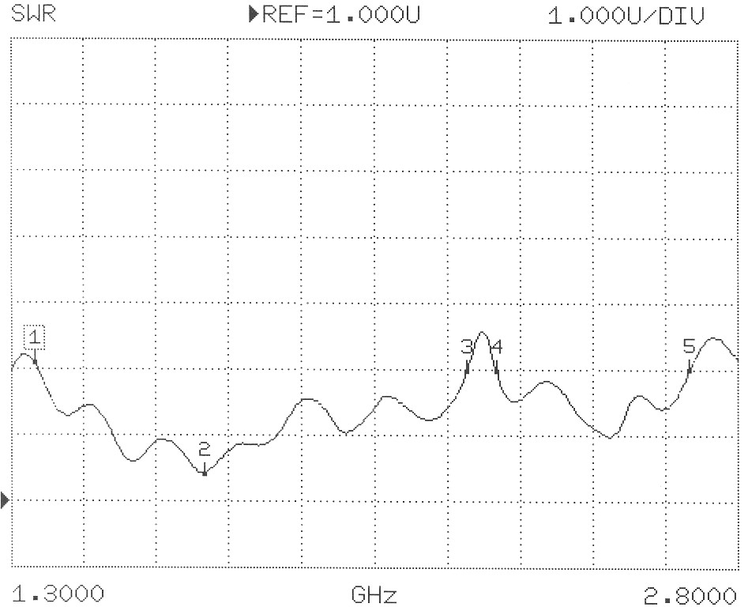
1
3
2

Fig. 2. Measured SWR.

Elevation
Azimuth
5 dB/Div
z
x

1.35 GHz 2.00 GHz 2.70 GHz

Fig. 3. Typical measured elevation and azimuth radiation patterns.
The patterns are fairly symmetrical in azimuth even though the helmet is physically not symmetrical in the azimuth plane. The elevation patterns are broader than a typical whip or monopole antenna. This is generally a desirable feature since it accommodates a wider range of helmet or head orientations. Additionally, the broad elevation coverage can be utilized in applications that call for hemispherical coverage yet can tolerate a pattern dip in zenith.
The gain of this antenna is fairly good, as will be discussed in the next section in comparison with the performance of a standard whip antenna commonly in use. Therefore, it is fair to state that this antenna is quite efficient, that the loss due to the helmet is estimated to be less than 1 dB, and that further impedance matching would enhance its gain by 0.2 to 1.2 dB, depending on the specific frequency.
IV. Key Advantages of This Helmet Antenna over Whip antenna
The yardstick for RF performance is generally set by the whip antenna. Fig. 4 illustrates some key advantages of this helmet antenna over a common whip antenna. The helmet antenna’s performance advantage is its omnidirectional azimuth gain pattern coverage, versus the whip’s 20 dB null due to body blockage, as shown in the figure. The second is the wide bandwidth versus the whip’s narrow resonant bandwidth.
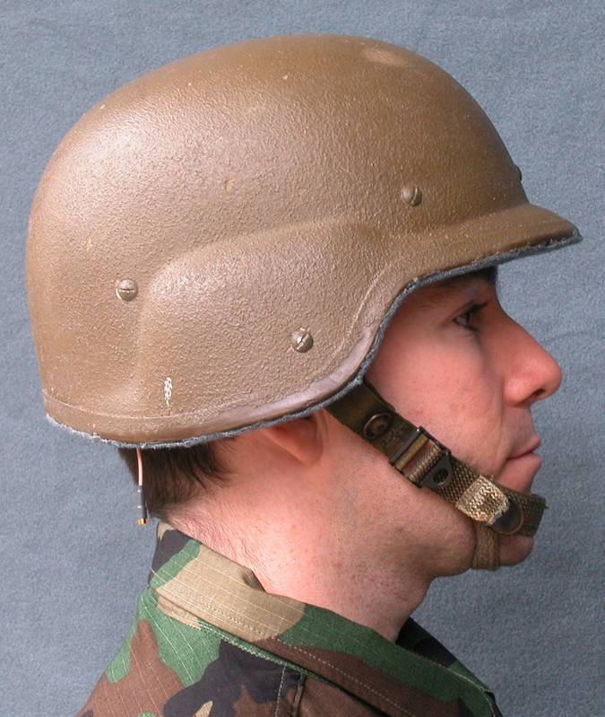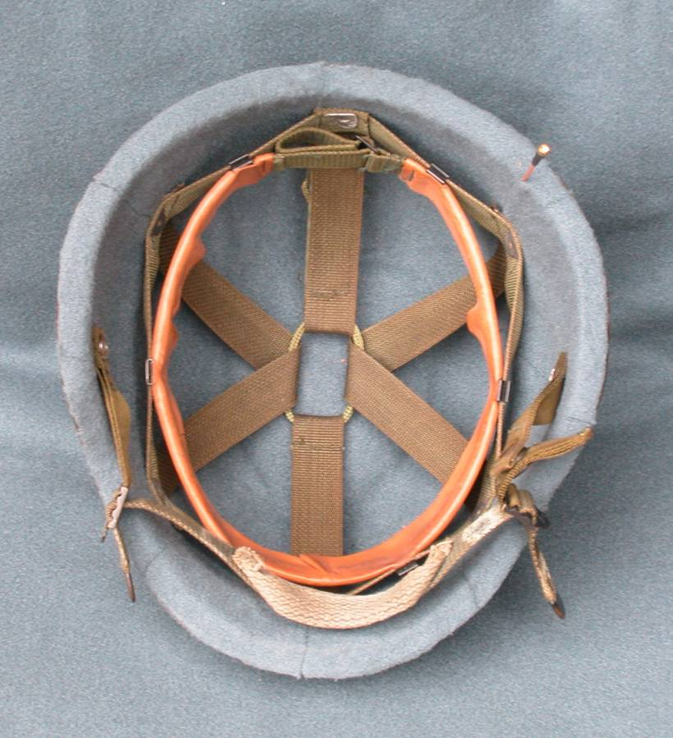
Good Comms In All Directions
No Body Blockage !
WANG BODY WEARABLE HELMET ANTENNA
Quick Connect / Disconnect Connector
No Comms In This Direction
Body Blocks
Comm in Forward Direction !
TYPICAL DISMOUNTED WHIP ANTENNA
vs
Covers Multiple Radio Waveform (1350-2700 MHz)
Antenna Weight : 4 oz (can be reduced to 2 oz)
Can Be Retro-Fitted To Existing Helmets In Field
Cost Effective - Reduced Attrition Rates

Fig. 4. Advantages of the helmet antenna over a common whip antenna.
The weight of the whole antenna assembly, including the feed cable and snap-on connector, is about 4 oz, but can be reduced to a couple of oz. Although the feed cable assembly is objectionable to some users, it gained acceptance recently due to the establishment of other helmet-mounted devices, most of which carry a cable connection.
The helmet antenna is more rugged and safer (having lower radiation hazard and “softer” structure) than the whip antenna. Its compatibility with other helmet-mounted gears is illustrated in Fig. 5. The helmet antenna needs only a circumferential band, as marked in stripes in Fig. 5, near the top of the helmet, which is clear of obstructions so that electromagnetic waves can radiate omnidirectionally. Any object on the “forbidden zone” will interfere with the radiation. However, the interference by such objects is usually not detrimental, since the electromagnetic wave does not require an absolute “line-of-sight” connection as an optical link would.

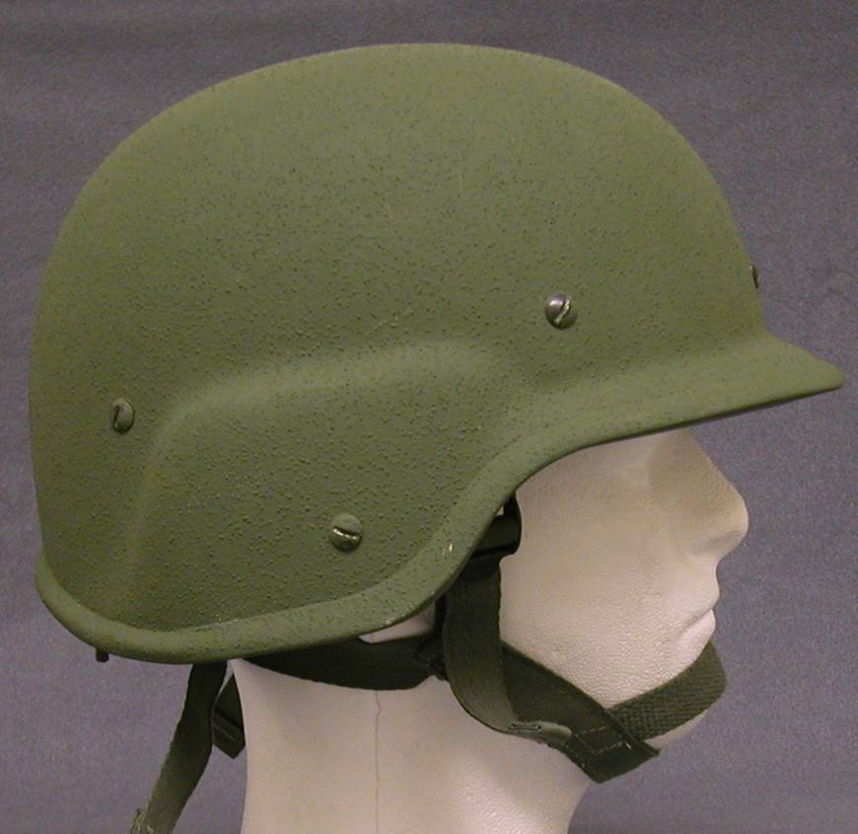
No obstructions allowed in the annular zone

Fig. 5. Annular zone on helmet clear of obstructions for optimal performance.

V. Conclusion
A new class of helmet antennas with omnidirectional pattern has been developed. Its radiation performance is considerably superior to that of conventional resonant whip antennas for terrestrial field applications ― over a much wider bandwidth and with more stable connectivity regardless of the wearer’s body movement and orientation. In addition, the helmet antenna has other practical advantages over the whip antenna. Thus, this helmet antenna appears to be a viable solution for many real-world applications.

References

- J. J. H. Wang, J. K. Tillery, K. E. Bohannan, and G. T. Thompson, “Helmet-Mounted Smart Array Antenna,” 1997 IEEE Antennas and Prop. Symp., Montreal, Canada, pp. 410-413, July 1997.
- J. K. Tillery, G. T. Thompson, and J. J. H. Wang, “Low-Power Low-Profile Multifunction Helmet-Mounted Smart Array Antenna,” 1999 IEEE Antennas and Prop. Symp., Orlando, Florida, pp. 1554-1557, July 1999.
- R. C. Adams, R. S. Abramo, J. F. Moore, and J. L. Parra, “COMWIN Antenna System Fiscal Year 2000 Report,” Technical report, SPAWAR Systems Center, San Diego, CA, Sept. 2000.
- J. Lebaric and A. Tan, “Ultrawideband Helmet Antenna,” 2000 Asia-Pacific Microwave Conference, Sydney, Australia, pp. 1477-1481, December 2000.
- Q. Wu, R. Jin, and X. Huang, “A Conformal Archimedean Spiral Antenna for Ultrawide-band Systems,” PIERS (Progress in Electromagnetic Research Symposium) 2005, Hangzhou, China, August 2005.
- J. J. H. Wang, D. J. Triplett, and C. J. Stevens, “Body Borne Antennas,” Final Report A-119, Wang Electro-Opto Corporation, Marietta, GA 30067, Contract DAAB07-03-C-J608 sponsored by U.S. Army CERDEC, February 2005. (Distribution limited to U.S. government)
- J. J. H. Wang and V. K. Tripp, “Design of Multioctave Spiral-Mode Microstrip Antennas,” IEEE Trans. Ant. Prop., March 1991; also U.S. Patents #5,313,216, May 17, 1994; #5,453,752, Sept. 26, 1995; #5,589,842, Dec. 31, 1996.
- J. J. H. Wang, “The Spiral as a Traveling Wave Structure for Broadband Antenna Applications,” Electromagnetics, 20-40, July-August 2000; also U.S. Patents #5,508,710, April 16, 1996 and #5,621,422, April 15, 1997.
- J. J. H. Wang and J. K. Tillery, “Broadband Miniaturized Slow-Wave Antenna,” U.S. patent #6,137,453, October 24, 2000; Taiwan patent #138931, July 21, 2001; China patent #191646, January 19, 2005.
- J. J. H. Wang, C. J. Stevens, and D. J. Triplett, “Ultra-wideband Omnidirectional Conformable Low-Profile Mode-0 Spiral-Mode Microstrip (SMM) Antenna,” 2005 IEEE Antennas and Prop. Symp., Washington, DC, July 2005.

